SMART WATER FOUNTAIN

Implementing IoT (Internet of Things) sensors in public water fountains can greatly enhance their efficiency, hygiene, and sustainability. Here's an overview of the potential contents and features for such a system:

1. \*\*Water Quality Monitoring:\*\*

- IoT sensors to continuously monitor water quality for impurities, pH levels, and contaminants.

- Alerts and notifications for maintenance or water treatment when needed.

2. \*\*Flow Monitoring:\*\*

- Sensors to monitor water flow, detect leaks, and optimize water usage to prevent waste.

- Automatic shutoff valves in case of excess flow or leaks.

3. \*\*Usage and Foot Traffic Monitoring:\*\*

- IoT devices to track usage patterns, foot traffic, and peak times of fountain usage.

- Insights to optimize maintenance schedules and water fountain placement.

4. \*\*Remote Control and Management:\*\*

- Centralized control to adjust water pressure, temperature, and other settings remotely.

- Real-time monitoring and management of multiple fountains from a central hub.

5. \*\*Hygiene Monitoring:\*\*

- Sensors to detect the presence of individuals and trigger automatic sanitation procedures after usage.

- Monitoring cleanliness levels and scheduling cleaning based on usage patterns.

6. \*\*User Feedback and Engagement:\*\*

- Implement touch-screen interfaces or mobile apps to provide information about the fountain, water quality, and sustainability.

- Collect user feedback to improve the overall experience and maintenance protocols.

7. \*\*Energy Efficiency:\*\*

- Implement solar panels and energy-efficient components to power the IoT sensors and reduce the system’s carbon footprint.

8. \*\*Smart Payments and Donations:\*\*

- Enable contactless payments or donations for water usage to fund maintenance and improvements.

- Provide insights into funding usage and community contributions.

9. \*\*Predictive Maintenance:\*\*

- Use machine learning algorithms to predict maintenance needs based on sensor data, reducing downtime and enhancing overall efficiency.

10. \*\*Water Conservation Initiatives:\*\*

- Encourage water conservation through real-time monitoring and data-driven campaigns.

- Display water consumption statistics to raise awareness of responsible water usage.

By integrating these features, public water fountains can become more intelligent, efficient, and sustainable, ultimately enhancing the overall public experience while contributing to environmental goals.

Project objectives:

1. \*\*Real-time Water Fountain Monitoring:\*\*

- Utilize IoT sensors to provide continuous monitoring of water quality, flow rates, and operational status in real-time.

- Enable instant notifications and alerts for any anomalies, allowing swift response and maintenance.

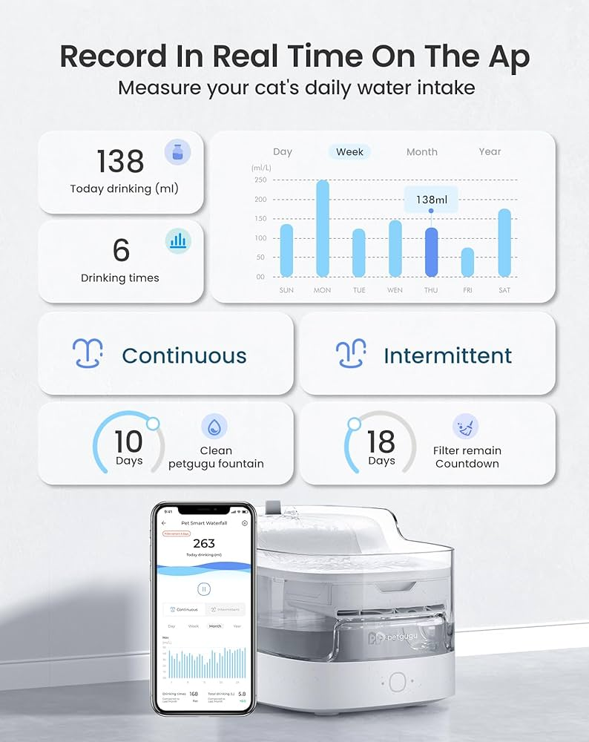

2. \*\*Efficient Water Usage:\*\*

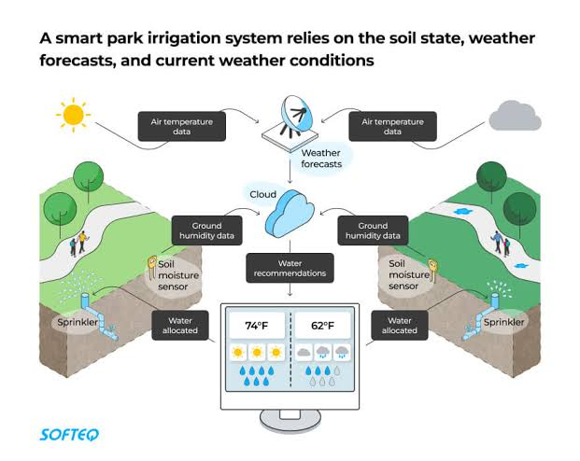 - Implement IoT-controlled water flow mechanisms to optimize water usage based on demand and foot traffic.

- Utilize sensors to detect usage patterns and adjust water dispensing accordingly, minimizing waste.

3. \*\*Malfunction Detection:\*\*

- Utilize IoT sensors to detect malfunctions or irregularities in water fountains, such as leaks, unusual flow rates, or pump failures.

- Trigger automatic alerts to maintenance teams for prompt resolution and minimize downtime.

4. \*\*Resident Awareness:\*\*

- Utilize interactive displays or mobile apps to inform residents about water quality, fountain usage data, and conservation tips.

- Engage the community through alerts on fountain maintenance schedules, encouraging responsible water usage, and participation in conservation efforts.

These measures collectively ensure efficient water usage, proactive malfunction detection, and enhanced resident awareness, fostering a sustainable and well-maintained public water fountain infrastructure.

Real time Transit information platform;

1. \*\*User-Friendly Interface:\*\*

- Design a clean and intuitive user interface (UI) that is easy to navigate and provides a seamless user experience.

2. \*\*Home Screen:\*\*

- Display a map showcasing the user’s current location and nearby parking areas.

- Include a search bar and filters to allow users to specify their parking preferences.

3. \*\*Real-Time Parking Availability:\*\*

- Integrate real-time data from parking sensors or parking management systems to display the availability of parking spots in various locations.

- Use color coding or icons to represent parking availability (e.g., green for available, red for full).

4. \*\*Location Details:\*\*

- Upon selecting a parking location, provide detailed information such as address, rates, types of parking (e.g., street parking, garage), and hours of operation.

5. \*\*Booking and Reservations:\*\*

- Offer an option to reserve a parking spot in advance if the facility supports reservations.

- Allow users to select a date and time for their reservation and proceed to the booking process.

6. \*\*User Profile:\*\*

- Implement a user profile section where users can save their vehicle information, payment methods, and favorite parking spots.

7. \*\*Payment Integration:\*\*

- Integrate a secure payment gateway to allow users to pay for parking within the app.

- Provide digital receipts and transaction history for users to track their spending.

8. \*\*Notifications:\*\*

- Set up push notifications to alert users about their upcoming reservations, parking time limits, and promotions related to parking.

9. \*\*Feedback and Reviews:\*\*

- Allow users to provide feedback and reviews for parking locations, encouraging a community-driven rating system.

10. \*\*Accessibility and Inclusivity:\*\*

- Ensure the app is accessible to people with disabilities, following best practices for inclusive design and providing accessibility features.

11. \*\*Help and Support:\*\*

- Include a help center or support section to assist users with any issues, FAQs, or contact options for customer support.

This plan focuses on creating a mobile app interface that offers real-time parking availability information, streamlined booking, and a user-friendly experience for finding and reserving parking spaces.

Integration approach:

1. \*\*Sensor Data Acquisition:\*\*

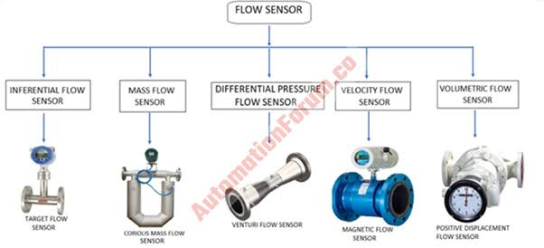 - IoT sensors (e.g., flow rate, pressure sensors) continuously collect data related to water fountain parameters, such as flow rates, pressure levels, and water quality.

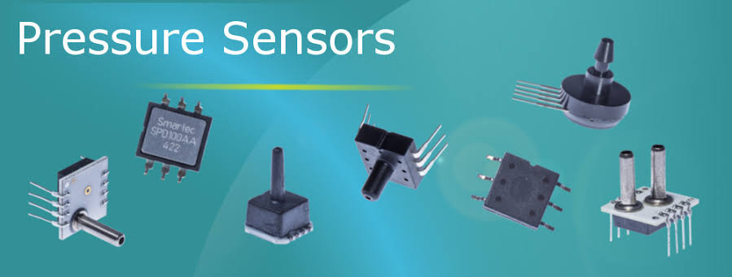

2. \*\*Local Processing and Aggregation:\*\*

- Implement local processing capabilities within the sensors to aggregate and process the collected data in real-time.

- Apply basic analytics or filtering to reduce data noise and ensure only relevant information is transmitted.

3. \*\*Communication Protocol:\*\*

- Choose a suitable communication protocol (e.g., MQTT, HTTP, CoAP) for efficient and secure data transmission from sensors to the water fountain status platform.

4. \*\*Edge Computing (Optional):\*\*

- Integrate edge computing devices near the sensors to perform additional data processing and analysis before sending the refined data to the central platform.

5. \*\*Gateway Devices:\*\*

- Use gateway devices to aggregate data from multiple sensors within a local area and establish a connection to the central platform.

6. \*\*Data Transmission to Platform:\*\*

- Send the processed and aggregated data from the sensors or gateway devices to the designated server or cloud platform using the chosen communication protocol.

7. \*\*API Integration:\*\*

- Create appropriate APIs on the water fountain status platform to receive data from the sensors, ensuring proper authentication and data validation.

8. \*\*Data Storage and Database Integration:\*\*

- Store the received sensor data in a database for historical analysis and future reference.

9. \*\*Real-Time Dashboard and Monitoring:\*\*

- Develop a real-time dashboard on the platform to visualize the incoming sensor data, providing insights into water fountain status and performance.

10. \*\*Alerts and Notifications:\*\*

- Implement an alerting system to notify relevant stakeholders in case of abnormal sensor readings or fountain malfunctions.

11. \*\*Scalability and Redundancy:\*\*

- Design the integration approach to be scalable, allowing for the addition of more sensors and easy integration with other IoT systems.

- Implement redundancy measures to ensure data integrity and platform availability.

This integration approach ensures efficient and secure data transmission from IoT sensors to the water fountain status platform, enabling real-time monitoring and timely response to maintain optimal water fountain performance.